Practical : 21

## Aim: Create a webpage to display the information about user on his homepage once he has logged in through the login form

Login.aspx

<%@ Page Language="vb" AutoEventWireup="false" CodeBehind="Login.aspx.vb" Inherits="Practical_21.Login" %>

<!DOCTYPE html>

<html xmlns="http://www.w3.org/1999/xhtml">

<head runat="server">

<title></title>

</head>

<body>

<form id="form1" runat="server">

<div style="font-weight: 700">

Login<br />

<br />

Username :

<asp:TextBox ID="txtUsername" runat="server" />

<br /><br />

Password :

<asp:TextBox ID="txtPwd" runat="server" TextMode="Password"/>

<br /><br />

<asp:Button ID="btnSubmit" runat="server" Text="Login" />

</div>

</form>

</body>

</html>

Login.aspx.vb

Public Class Login

Inherits System.Web.UI.Page

Protected Sub Page_Load(ByVal sender As Object, ByVal e As System.EventArgs) Handles Me.Load

End Sub

Protected Sub btnSubmit_Click(sender As Object, e As EventArgs) Handles btnSubmit.Click

Dim con As New SqlClient.SqlConnection("Data Source=(LocalDB)\MSSQLLocalDB;AttachDbFilename=C:\Users\ISHAN\Desktop\Databases\User.mdf;Integrated Security=True;Connect Timeout=30")

Dim ad As New SqlClient.SqlDataAdapter("select * from UserData where Username = '" & txtUsername.Text & "' and Password = '" & txtPwd.Text & "' ", con)

Dim dt As New DataTable

con.Open()

ad.Fill(dt)

con.Close()

If dt.Rows.Count > 0 Then

Session("username") = txtUsername.Text

Response.Redirect("Home.aspx")

Else

Response.Write("<font color='red'>Invalid Username/Password</font>")

End If

End Sub

End Class

Home.aspx

<%@ Page Language="vb" AutoEventWireup="false" CodeBehind="Home.aspx.vb" Inherits="Practical_21.Home" %>

<!DOCTYPE html>

<html xmlns="http://www.w3.org/1999/xhtml">

<head runat="server">

<title></title>

</head>

<body>

<form id="form1" runat="server">

<div>

Username :

<asp:Label ID="lblUsername" runat="server"/>

<br /><br />

Age :

<asp:Label Id="lblAge" runat="server" />

</div>

</form>

</body>

</html>

[Home.aspx.vb](http://Home.aspx.vb)

Public Class Home

Inherits System.Web.UI.Page

Protected Sub Page_Load(ByVal sender As Object, ByVal e As System.EventArgs) Handles Me.Load

If Session("username") = "" Then

Response.Redirect("Login.aspx")

Else

Dim con As New SqlClient.SqlConnection("Data Source=(LocalDB)\MSSQLLocalDB;AttachDbFilename=C:\Users\ISHAN\Desktop\Databases\User.mdf;Integrated Security=True;Connect Timeout=30")

Dim ad As New SqlClient.SqlDataAdapter("select Username,Age from UserData where Username = " & Session("Username"), con)

Dim dt As New DataTable

con.Open()

ad.Fill(dt)

con.Close()

lblUsername.Text = dt.Rows(0).Item(0)

lblAge.Text = dt.Rows(0).Item(1)

End If

End Sub

End Class

Output :

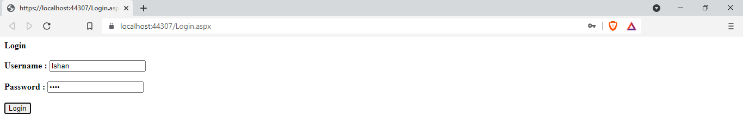

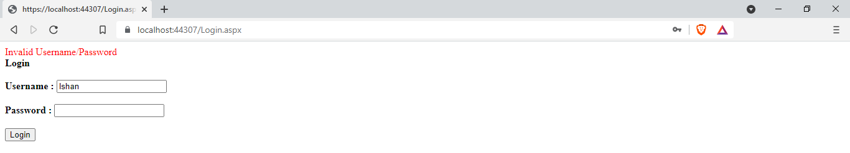

On Successful Login :

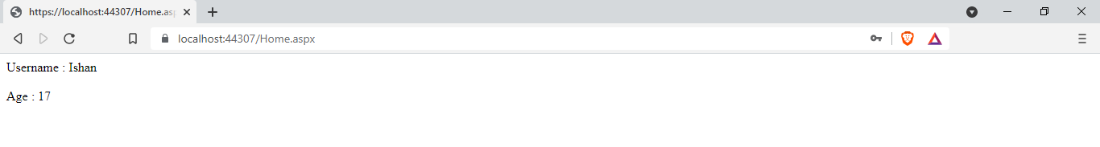

|  |  |  |  |
| --- | --- | --- | --- |
| Start Date | End/Sign Date | Faculty Sign | Remarks/Grade |
|  |  |  |  |